https://p11tecza.edupage.org/text/?text=text/text2&subpage=12
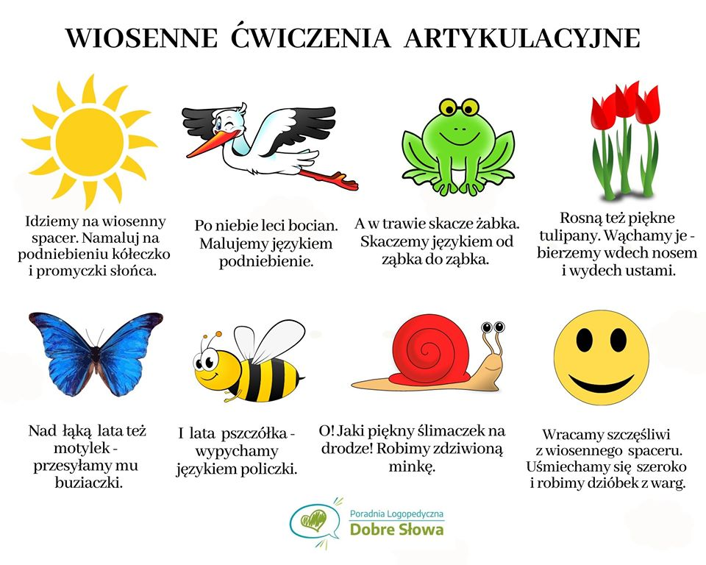

https://www.google.com/url?sa=i&url=https%3A%2F%2Fharmonia.edu.pl%2Fpl%2Fp%2FZOSTANE-PROGRAMISTA%2F1652&psig=AOvVaw0yIcvXQwXcn0caF6osRU_n&ust=1592335088853000&source=images&cd=vfe&ved=0CAkQjhxqFwoTCLDXms3EhOoCFQAAAAAdAAAAABAY
